* List of Use Cases:

|  |  |  |
| --- | --- | --- |
| **Code** | **Use Case Name** | **Meaning/Note** |
| A1 | Create Account | Allow users to create their account and grant permission to them if they’re manager |
| A2 | Sign-in | Allow users to sign-in NFLM |
| A3 | Create Team Profile | Allow remove, update, view team profile |
| A4 | Scheduling Match | Allow remove, update, view match schedule |
| A5 | Record Match Result | Allow remove, update, view match result |
| A6 | Player Lookup | Provide player information |
| A7 | Create Tournament Report | Make leaderboard, make scorers list, view tournament report |
| A8 | Change or Add Regulations | Add, change or view current regulation in database |

* Use Case Diagram:

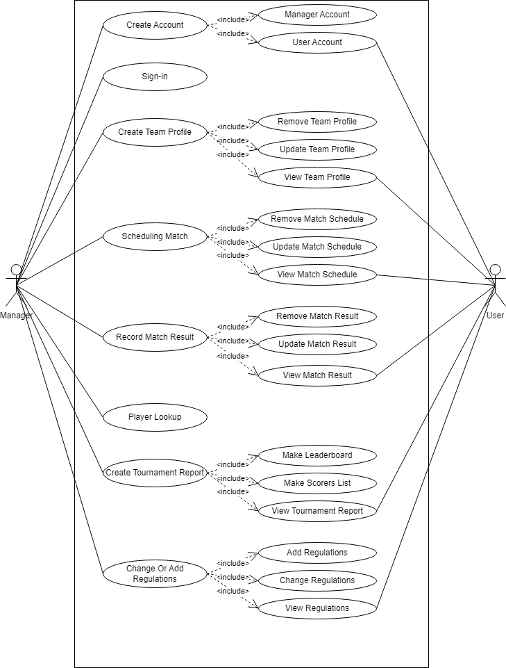

* Use Case Specification:

1. Use case A1, Create account

|  |  |
| --- | --- |
| **A1** | **UCA1** |
| **Name** | Create account |
| **Summary** | Create user account |
| **Actor** | User, Manager |
| **Main event flow** | 1. The system suggests providing information to create an account. 2. Users provide necessary information to create an account. 3. Users propose recording. 4. The system performs a verification check and records the account creation according to the information provided by the user. 5. The system sends a verification email to the user's email address. 6. The system notifies that the account has been successfully created. |
| **Alternative event flows** | The username or email information already exists in the database:   1. The system notifies that the username or email already exists in the database. 2. The system suggests providing the information again. |
| **Preconditions** | No |
| **Special requirements** | 1. The interface must be user-friendly. 2. The recording time must not exceed 1 minute. |

1. Use case A2, Sign-in

|  |  |
| --- | --- |
| **A2** | **UCA2** |
| **Name** | Sign-in |
| **Summary** | Allow user to access to NFLM system |
| **Actor** | User, Manager |
| **Main event flow** | 1. User type username and password 2. User request sign-in 3. The system checks whether the user exists in the database or not. 4. The system grants access permission to the user to access the system. |
| **Alternative event flows** | User does not exist in the database:   1. The system notifies that the user does not exist.   User exists but has entered incorrect username or password:   1. The system notifies that the username or password is incorrect. |
| **Preconditions** | No |
| **Special requirements** | 1. The interface must be user-friendly. 2. The recording time must not exceed 1 minute. |

1. Use case A3, Create team profile

|  |  |
| --- | --- |
| **A3** | **UCA3** |
| **Name** | Create team profile |
| **Summary** | Create team profile based on necessary information |
| **Actor** | Manager |
| **Main event flow** | 1. The system requests necessary information to create a team profile. 2. The user provides the required information about the team. 3. The user requests to confirm the team profile. 4. The system verifies and records the team profile based on the information provided by the user. 5. The system notifies the user that the team profile has been successfully recorded. |
| **Alternative event flows** | Information provided for update does not comply with regulations:   1. The system notifies which information does not comply with regulations. 2. The system requests the user to provide the correct information. |
| **Preconditions** | No |
| **Special requirements** | 1. The interface must be user-friendly. 2. The recording time must not exceed 1 minute. |

1. Use case A4, Scheduling match

|  |  |
| --- | --- |
| **A4** | **UCA4** |
| **Name** | Scheduling match |
| **Summary** | Create match schedule for tournament |
| **Actor** | Manager |
| **Main event flow** | 1. The system requests some information to create a schedule for a round of matches. 2. The user provides necessary information. 3. The user suggests recording the information. 4. The system updates according to the provided information. 5. The system notifies the user of a successful update. |
| **Alternative event flows** | Information provided for update does not comply with regulations:   1. The system notifies which information does not comply with regulations. 2. The system requests the user to provide the correct information. |
| **Preconditions** | No |
| **Special requirements** | 1. The interface must be user-friendly. 2. The recording time must not exceed 1 minute. |

1. Use case A5, Record match result

|  |  |
| --- | --- |
| **A5** | **UCA5** |
| **Name** | Record match result |
| **Summary** | Record result from every match with necessary information |
| **Actor** | Manager |
| **Main event flow** | 1. The system requests necessary information to record the result of a match. 2. The user provides the required information. 3. The user requests to update the information. 4. The system updates the information based on the user's input. 5. The system notifies that the update was successful. |
| **Alternative event flows** | Incorrect information provided for updating:   1. The system notifies which information does not comply with the regulations. 2. The system suggests providing the correct information again. |
| **Preconditions** | No |
| **Special requirements** | 1. The interface must be user-friendly. 2. The recording time must not exceed 1 minute. |

1. Use case A6, Player lookup

|  |  |
| --- | --- |
| **A6** | **UCA6** |
| **Name** | Player lookup |
| **Summary** | Lookup for player with matching information |
| **Actor** | User, Manager |
| **Main event flow** | 1. The system suggests providing one of the necessary information to look up. 2. The user provides the necessary information. 3. The user requests to look up. 4. The system searches for players based on the information provided by the user. 5. The system displays the found players. |
| **Alternative event flows** | Invalid search information:   1. The system will notify which information is invalid 2. The system suggests providing valid information.   Player not found:   1. The system will notify that the player is not found based on the provided information. 2. The system suggests providing more accurate or different information to search for the player. |
| **Preconditions** | No |
| **Special requirements** | 1. The interface must be user-friendly. 2. The recording time must not exceed 1 minute. |

1. Use case A7, Create tournament report

|  |  |
| --- | --- |
| **A7** | **UCA7** |
| **Name** | Create tournament report |
| **Summary** | Make leaderboard and scorer list |
| **Actor** | Manager |
| **Main event flow** | 1. The system requests for the date to create a leaderboard and a list of top goal scorers. 2. The user provides necessary information. 3. The user requests for a lookup. 4. The system filters the ranking of teams based on relevant information. (Leaderboard) 5. The system searches for relevant information about goal scorers, number of goals. (List of top goal scorers) |
| **Alternative event flows** | Invalid search information:   1. The system notifies which information is invalid 2. The system suggests providing the correct information |
| **Preconditions** | No |
| **Special requirements** | 1. The interface must be user-friendly. 2. The recording time must not exceed 1 minute. |

1. Use case A8, Change or add regulations

|  |  |
| --- | --- |
| **A8** | **UCA8** |
| **Name** | Change or add regulations |
| **Summary** | Allow manager to add or change current regulation |
| **Actor** | Manager |
| **Main event flow** | 1. The system displays the specified regulations.   If the user changes the current regulation:   1. The user selects a current regulation. 2. The user provides necessary information for the update (if desired). 3. The system updates the regulations based on the provided information.   If the user adds a new regulation:   1. The user provides necessary information about the new regulation. 2. The system adds the new regulation to the system based on the provided information. |
| **Alternative event flows** | No |
| **Preconditions** | No |
| **Special requirements** | 1. The interface must be user-friendly. 2. The recording time must not exceed 1 minute. |